SIMATS ENGINEERING
ASSESSMENT TOOL 3

COURSE NAME: Artificial Intelligence COURSE CODE: CSA17

COURSE OUTCOME COVERED
CO2: Experiment search and game-solving techniques such as Greedy Search, A*, CSP, Minimax, and Alpha-Beta pruning with heuristic functions for solving complex AI problems efficiently. (BL3)
Assessment Tool Weightage: 40%

Duration: 1 Hour
QUESTIONS: 3 Total Marks:30

Annexure A
Dry Run Evaluation

Code of Conduct:

I M Praneeth Kumar (Name / Reg No) certify that this submission is my original work and that I have adhered to the guidelines specified for this assessment.
I understand that any violation of academic integrity rules will result in disciplinary action.
M Praneeth Kumar
Signature of the student:

Annexure A
Dry Run Evaluation

- Question 1 – Breadth-First Search (BFS) Consider the following graph: A
/ \

B C

/ \ / \

D E F G

Task: Starting from node A, perform a Breadth-First Search (BFS). Complete the following table.

Iteration Queue Visited Node
1
2
3
4
5
6
7

Questions:

  - Write the BFS traversal order.
  - Show the queue contents after each iteration.

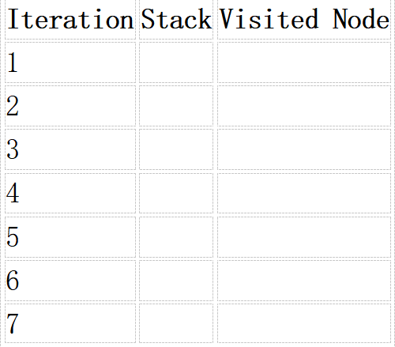
- Depth-First Search (DFS) Using the same graph,
A
/ \
B C
/ \ / \
D E F G

Perform Depth-First Search (DFS) starting from A. Complete the table.

- Initial State :
1 3 6
5 0 2
4 7 8

Goal State :
1 2 3
4 5 6
7 8 0

Task

Trace Breadth-First Search (BFS) until the goal state is reached. Fill in the table.
Iteration Current State Queue Before Expansion Queue After Expansion
1
2
3
4
5

Questions

- Which node is expanded in each iteration?
- How many states are generated in total?
- Write the complete solution path from the initial state to the goal state.
- Why does BFS always find the shortest solution in an unweighted 8-puzzle problem?

RUBRICS FOR CALCULATION

Criteria | Weightage (%) | Level 4 –  Exemplary (4) | Level 3 –  Proficient (3) | Level 2 –  Developing (2) | Level 1 –  Beginning (1)
Understandi ng of Search Problem | 20 | Clearly understands the search problem, initial state, goal state, and search strategy. | Understands the problem with minor misunderstandi ngs. | Demonstrates partial understanding of the search problem. | Shows little or no understanding of the search problem.
State Expansion and Dry Run Execution | 30 | Correctly traces every iteration, expands nodes accurately, and maintains the Queue/Stack/Priority Queue without errors. | Performs most iterations correctly with minor mistakes in state expansion or data structure updates. | Performs only some iterations correctly; several errors in tracing or node expansion. | Unable to correctly perform the dry run or expand states.
Application of Search Algorithm | 20 | Applies the selected algorithm (BFS/DFS/UCS)  correctly, following all algorithmic rules. | Applies the algorithm correctly with a few procedural errors. | Applies only basic algorithm steps with noticeable mistakes. | Fails to apply the correct search algorithm.
Accuracy of Solution Path | 20 | Identifies the correct traversal order/solution path and goal state with proper justification. | Solution path is mostly correct with minor errors. | Partially correct solution path; goal may not be reached correctly. | Incorrect or incomplete solution path.
Presentation and Logical Reasoning | 10 | Queue/Stack/Priority Queue updates, state diagrams, and explanations are neat, organized, and logically presented. | Presentation is clear with minor organizational issues. | Limited explanation and organization; reasoning is partially clear. | Poor presentation with unclear or missing reasoning.

1. Breadth-First Search (BFS) Given Graph
A
/ \
B C
/ \ / \
D E F G
BFS Dry Run Table
Iteration Queue (Before Dequeue) Visited Node

1 | A | A
2 | B, C | B
3 | C, D, E | C
4 | D, E, F, G | D
5 | E, F, G | E
6 | F, G | F
7 | G | G
Queue After Each Iteration Iteration Queue After Expansion
- B, C
- C, D, E
- D, E, F, G
- E, F, G
- F, G
- G
- Empty
Answers
- BFS Traversal Order
A → B → C → D → E → F → G
- Queue Contents After Each Iteration
  - Iteration 1: B, C
  - Iteration 2: C, D, E
  - Iteration 3: D, E, F, G
  - Iteration 4: E, F, G
  - Iteration 5: F, G
  - Iteration 6: G
  - Iteration 7: Empty
- Depth-First Search (DFS) Given Graph

A
/ \
B C
/ \ / \
D E F G
DFS Dry Run Table
Iteration | Stack | Visited Node
1 | A | A
2 | B, C | B
3 | D, E, C | D
4 | E, C | E
5 | C | C
6 | F, G | F
7 | G | G
DFS Traversal Order
A → B → D → E → C → F → G

- 8-Puzzle Problem Using BFS Initial State
1 3 6
5 0 2
4 7 8
Goal State
1 2 3
4 5 6
7 8 0
BFS Dry Run
Iteration Current State Queue Before
Expansion

Queue After Expansion

1 | 1 3 6 / 5 0 2 / 4 7  8 | Initial State | 4 Successor States
2 | First Successor | 4 States | 6 States
3 | Second Successor | 6 States | 8 States
4 | Third Successor | 8 States | 10 States
5 | Fourth Successor | 10 States | 12 States

Answers
- Which node is expanded in each iteration?
  - Iteration 1 – Initial State
  - Iteration 2 – First Successor

  - Iteration 3 – Second Successor
  - Iteration 4 – Third Successor
  - Iteration 5 – Fourth Successor

- How many states are generated in total?
Approximately 12 unique states are generated during the first five iterations (excluding repeated states).
- Complete Solution Path
Initial State 1 3 6
5 0 2
4 7 8
↓
Intermediate States
↓
Goal State 1 2 3
4 5 6
7 8 0
(The goal state is reached after several more BFS expansions, not within the first five iterations.)

- Why does BFS always find the shortest solution in an unweighted 8-puzzle problem?
  - BFS explores all states level by level.
  - Every move has the same cost (1 step).
  - The first time the goal state is reached, it is guaranteed to have the minimum number of moves.
  - Therefore, BFS always finds the shortest path in an unweighted search problem.
Result: BFS guarantees the optimal (shortest) solution for the 8-puzzle when all moves have equal cost.

